|  |  |  |  |
| --- | --- | --- | --- |
| **TITLE:** | AR-01 Auto Statement | | |
| **sop #:** | IT-03 | **revision #:** | 1 |
| **EFFECTIVE DATE:** | May 25, 2020 | | |
| **OWNER:** | Elhadj Diallo | | |

## REVIEWERS

|  |  |  |  |
| --- | --- | --- | --- |
| Name | tITLE | sIGNATURE | dATE |
| Elhadj Diallo | Business Intelligence Developer and Analyst | Signed | May 25, 2020 |
| Kazi Islam | Systems and Technical Analyst, TMS | Signed | May 25, 2020 |

## APPROVER

|  |  |  |  |
| --- | --- | --- | --- |
| Name | tITLE | sIGNATURE | dATE |
| TestDevUser | Test Dev user | Signed | May 25, 2020 |

# 1.0 purpose

To set up automated statements to the customers.

# 2.0 SCOPE

Covers process to setup auto statements for customers

# 3.0 equipment

N/A

# 4.0 definitions

|  |  |
| --- | --- |
| **Definition** | **Explanation** |
|  |  |

# 5.0 Responsibility

|  |  |
| --- | --- |
| **Responsibility** | **Activity** |
|  |  |

# 6.0 policy

## 6.1 GENERAL

1. Send email to Mark Gorelik (I.T.) advising him of the customer code in Epicor. The frequency of the auto statement. E.G. Monthly, Biweekly, Weekly and include the customers email address
2. Mark will set it up and send a confirmation email that it has been completed. If you need to check. Go to Explorer, under Customer statement listing and type in the customers’ name in the field as shown below and click find.

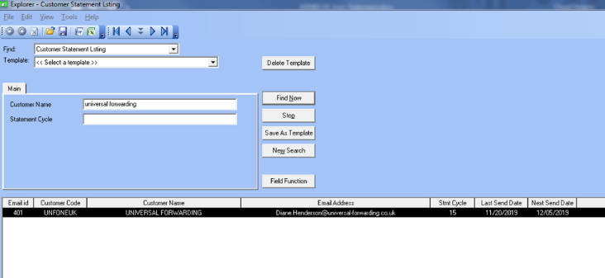

# 7.0 references

# 8.0 revision history

|  |  |  |
| --- | --- | --- |
| **Revision #** | **Revision Date** | **Description** |
|  |  |  |